

**Hardware Requirements & Design Document  
  
For The  
  
ACMEY Company Avionics Passenger Counter**

Document No: 800-HCMP-01

Revision: 0.1

|  |  |  |  |
| --- | --- | --- | --- |
| __________________________________________________ |  | | ___________ |
| Project Manager |  | Date | |
| __________________________________________________ |  | ___________ | |
| Technical Project Lead |  | Date | |
| __________________________________________________ |  | ___________ | |
| Principal Design Engineer |  | Date | |
| __________________________________________________ |  | ___________ | |
| Principal Quality Engineer |  | Date | |

|  |
| --- |
| **Notice**  This document and the information contained herein are the property of Airworthiness Certification Services LLC. Any reproduction, disclosure or use thereof is prohibited except as authorized in writing by Airworthiness Certification Services LLC. Recipient accepts the responsibility for maintaining the confidentiality of the contents of this document. |

|  |  |  |  |
| --- | --- | --- | --- |
| REVISIONS | | | |
| Rev | Reason/Description | Requested/  Changed By | Date |
| 0.1 | Initial draft | N/A |  |
|  |  |  |  |
|  |  |  |  |
|  |  |  |  |
|  |  |  |  |
|  |  |  |  |
|  |  |  |  |
|  |  |  |  |
|  |  |  |  |
|  |  |  |  |
|  |  |  |  |
|  |  |  |  |
|  |  |  |  |
|  |  |  |  |
|  |  |  |  |
|  |  |  |  |
|  |  |  |  |
|  |  |  |  |
|  |  |  |  |
|  |  |  |  |
|  |  |  |  |
|  |  |  |  |
|  |  |  |  |
|  |  |  |  |
|  |  |  |  |
|  |  |  |  |
|  |  |  |  |
|  |  |  |  |
|  |  |  |  |
|  |  |  |  |
|  |  |  |  |
|  |  |  |  |

**Table of Contents**

**Section Page**

1 Introduction 4

1.1 Scope 4

1.2 Organization 5

1.3 Subcontractor 5

1.4 Terms and Abbreviations 6

1.5 Applicable Documents 6

1.5.1 External Documents 6

1.5.2 Internal Documents 7

Hardware Configuration Management 7

1.6 Hardware Configuration Management Objectives 7

1.7 Hardware Configuration Management Methods & Tools 8

1.7.1 Compliance Matrix 9

1.8 Configuration Management Tools 10

1.9 Configuration Identification 10

1.9.1 HDL Source Code Configuration 11

2 Hardware Baselines 12

3 Hardware Releases 15

3.1 Hardware Configuration Index 15

3.2 Document Release 15

4 Problem Reporting and Resolution 15

4.1 CM Program Specific Roles 15

4.1.1 PR Roles 16

4.2 Change Control Board (CCB) 16

4.3 Developmental Problem Reporting 16

4.3.1 Problem Reporting Form 16

4.3.2 Open PR Management 18

4.3.3 Problem Report Path to Completion 18

4.3.3.1 Documents 19

4.3.3.2 Code 22

5 Change Control 23

5.1 Development Change Control 23

5.2 Change Review 23

5.3 Configuration Management Audit 23

5.4 Control Categories & Program FPGA Hardware Design Lifecycle Data 23

6 Storage and Retrieval 24

7 Environment Control & Tools 25

8 Sub-Tier Suppliers 26

# Introduction

This document presents the Configuration Management Plan for the ACMEY Company, Avionics Passenger Counter hardware development, hereby referred to as the Program.

## Scope

The purpose of this Hardware Configuration Management Plan (HCMP) is to establish the Configuration Management (CM) related policies and methods to be adopted and implemented during Lifecycle development for the development activities for the Avionics Passenger Counter (APC) Field Programmable Gate Array (FPGA) hardware. ACMEY will be responsible for formal release and production control (HC1) and developmental configuration management (HC2) for the FPGA hardware development project as outlined in this document.

This document describes the CM processes and procedures for establishing HC1 and HC2 level controls.

This plan specifically addresses hardware configuration management methods related to identification, change control, change review, status accounting, baseline development and review of program documentation and configuration items. In addition, this plan establishes and provides the basis for a uniform and concise CM policy during the hardware planning, requirements, design, code, integration, verification, and certification phases of the program.

Starting with the system requirements and extending through design and test documentation, the functional and allocated configurations of the development will be protected from uncoordinated and unauthorized changes. This protection will be provided by formal CM operations, including document identification, release, and change control procedures. This process continues throughout the service life of the equipment.

This document is prepared to satisfy the requirements set forth in RTCA/DO-254 section 10.1.5 and FAA and EASA guidance on problem reporting in draft AC/AMC20-152A.

## Organization



Figure 1-1: Independent Reporting Structure

## Subcontractor

ACMEY engineering and any subcontractor will adhere to this configuration management plan for the development CM control of the hardware developed under this program and the associated complex devices within.

## Terms and Abbreviations

AC Advisory Circular

CCA Circuit Card Assembly

CCB Change Control Board

CEH Complex Electronic Hardware

CM Configuration Management

CMP Configuration Management Plan

CM/V&V Configuration Management/Validation & Verification

COTS Commercial-Off-The-Shelf

DAL Design Assurance Level

DCO Design Change Order

EASA European Union Aviation Safety Agency

ECO Engineering Change Order

ERP Engineering Review Panel

FAA Federal Aviation Administration

FPGA Field Programmable Gate Array

HAS Hardware Accomplishment Summary

HC1 Hardware Change Control Category 1

HC2 Hardware Change Control Category 2

HCI Hardware Configuration Index

HCM Hardware Configuration Management

HCMP Hardware Configuration Management Plan

HDD Hardware Detailed Design

HDL Hardware Description Language

HDP Hardware Development Plan

HDS Hardware Design Standard

HPA Hardware Process Assurance

HPAP Hardware Process Assurance Plan

HRD Hardware Requirements Document

HRS Hardware Requirements Standard

HTP Hardware Test Procedures

HTR Hardware Test Results

HVVP Hardware Validation and Verification Plan

HVVS Hardware Validation and Verification Standard

HW Hardware

HWCI Hardware Configuration Item

PCB Printed Circuit Board

PHAC Plan for Hardware Aspects of Certification

PLD Programmable Logic Device

PR Problem Report

RTCA Radio Technical Commission for Aeronautics

## Applicable Documents

The following documents are listed for reference only. Each document is applicable to this plan only to the extent specified herein.

### External Documents

| Table 1‑1: External Documents | |
| --- | --- |
| **Document Number** | **Title** |
| RTCA/DO-178C | Software Considerations in Airborne Systems and Equipment Certification |
| RTCA/DO-254 | Design Assurance Guidance for Airborne Electronic Hardware |
| 8110.49A | Software Approval Guidelines |
| 8110.105A | Simple and Complex Electronic Hardware Approval Guidance |
| AC/AMC 20-152A | Advisory Circular, RTCA Inc., Document DO-254, Design Assurance for Airborne Electronic Hardware (draft) |
| AC/AMC 00-71 | Best Practices for Management of open Problem reports (draft) |
| AC/AMC 20-189 | Management of Open Problem Reports (draft) |

### Internal Documents

| Table 1‑2: Hardware Plans & Standards | | | | |
| --- | --- | --- | --- | --- |
| **Hardware Plans** | | | | |
| Plan for Hardware Aspects of Certification | 4.1(1,2,3,4) | S | HC1 | 800-PHAC-01 |
| Hardware Development Plan | 4.1(1,2,3,4) |  | HC2 | 800-HDP-01 |
| Hardware Verification Plan | 4.1(1,2,3,4); 6.2.1(1) | S | HC2 | 800-HVVP-01 |
| Hardware Configuration Management Plan | 4.1(1,2,3,4); 7.1(3) |  | HC1 | 800-HCMP-01 |
| Hardware Process Assurance Plan | 4.1(1,2,4); 8.1(1,2,3) |  | HC2 | 800-HPAP-01 |
| **Hardware Design Standards** | | | | |
| Requirements Standards | 4.1(2) |  | HC2 | 800-HRS-01 |
| Hardware Design Standards  Coding Standards | 4.1(2) |  | HC2 | 800-HDS-01 |
| Validation and Verification Standards | 4.1(2) |  | HC2 | 800-HVVS-01 |
| **Hardware Design Data** | | | | |
| Hardware Requirements | 5.1.1(1,2); 5.2.1(2); 5.3.1(2); 5.4.1(3); 5.5.1(1,2,3); 6.1.1(1,2); 6.2.1(1) |  | HC1 | 800-HRD-01 |

# Hardware Configuration Management

This section contains the description of the policies, procedures, methods and standards to be used to identify, manage and control the hardware lifecycle data developed under the DO-254 design assurance standard.

## Hardware Configuration Management Objectives

| Table 1‑3: DO-254 Configuration Management Process Objectives | | |
| --- | --- | --- |
|  | **Objective** | **Method of Compliance** |
| **1** | Configuration items are uniquely identified and documented.  (Reference 7.1-1) | Document numbers are assigned and controlled as part of IEE system. Each document has a unique number and subsequent version of that document is further identified with a revision. |
| **2** | Consistent and accurate replication of configuration items is ensured.  (Reference 7.1-2) | PACT ensures versions of all development data are controlled throughout the development process with the ability to show traceability from development baselines and revisions under the development process.  Backup and Archival processes insure protection in the case of a disaster or failure of the system. |
| **3** | A controlled method of identifying and tracking modification to configuration items is provided.  (Reference 7.1-3) | See section 2.4 for configuration management identification methods.  The Hardware Configuration Index (HCI) controls the final version of all assemblies and sub- assemblies which make up the final design.  Tracking of all lifecycle item issues is performed and captured in PACT. |

## Hardware Configuration Management Methods & Tools

The following sections describe the configuration management methods, activities and tools that will be used to maintain HCM records for the project. Two categories associated with the configuration management of data items are defined: Hardware Control category 1 (HC1) and Hardware Control category 2 (HC2). HC1 requires all configuration management activities to be performed while HC2 is less restrictive. Applicable control categories are identified with their associated lifecycle data in the project specific Plan for Hardware Aspects of Certification (PHAC) life cycle data table.



Figure 1-1: Document Flow

For this project, Subversion (SVN), an open-source tool, is used as the development code repository and version control system. Once the code has reached a level of refinement sufficient for a code review, the code files will be placed into the Process Artifact and Compliance Tool (PACT) where a baseline of the image will be created and a peer review can be performed and recorded. PACT meets the objectives and activities in DO-254 for HC1 per DO-254 section 7.0. Figure 0-1 shows the flow of lifecycle items from Engineering. Once any lifecycle item in the form of a document has been created in PACT and is ready for review, it is baselined. The document is reviewed and if any defects are found or changes need to be made, action items are created, approved, implemented and the change verified. Once all action item and document comments are verified and closed, the document is released which results in a letter revision. The letter revision then becomes the formal baseline for any further changes.

### Compliance Matrix

Table 0‑2: DO-254 Compliance Matrix, provides a compliance matrix to the sections of this document describing the methods and life cycle data meeting the applicable RTCA/DO-254 activities in support of the DO-254 CM objectives.

| Table 1‑4: DO-254 Compliance Matrix | | | | |
| --- | --- | --- | --- | --- |
| **DO-254 reference** | **Configuration Management Activity** | **HC1** | **HC2** | **Mapping to HCMP for HC2** |
| 7.2.1 | Configuration Identification | X | X | Section 2.4 |
| 7.2.2 (1), (2), (3) | Baselines | X |  | Section 3 |
| 7.2.2 (4) | Baseline Traceability | X | X | Section 3 |
| 7.2.3 | Problem reporting | X |  | Section 5 |
| 7.2.4 (1), (2) | Change Control - integrity and identification | X | X | Section 6 |
| 7.2.4 (3), (4), (5), (6) | Change Control - records, approval and traceability | X |  | Section 5, 6 |
| 7.2.5 (1) | Release | X |  | Section 4.2 |
| 7.2.5 (2) | Retrieval | X | X | Section 7 |
| 7.2.5 (3) | Data retention | X | X | Section 7 |
| 7.2.5 (4a) | Protection Against Unauthorized Changes | X | X | Section 6 |
| 7.2.5 (4b), (4c), (4d) | Media Selection, refreshing, Duplication | X |  | Section 7 |

## Configuration Management Tools

PACT will be used for version control of all artifacts produced within this hardware project. SVN will be used during any HDL code development and an open-source version control system.

Once the development code within SVN is ready for review, it will be transferred to PACT. During development, SVN allows the use of the Microsoft Windows-based explorer system. The SVN client is accessed by Windows Explorer providing a way to access all SVN features.

For issue tracking (problem reporting and change control), the PACT Problem Report (PR) is used as described in the section, “Hardware Configuration Management Methods & Tools”. For peer reviews, the findings and action items are stored in PACT as evidence of process during any audits.

The list of the configuration management tools used in this project and their respective version numbers is shown in the section 7.

The versions of the configuration management tools will remain stable during project development. If critical tool updates are released, the tools will be updated, the version updated in the Hardware Environment Configuration Index and the reason/impact reported in the Hardware Accomplishment Summary.

## Configuration Identification

All program specific hardware life cycle data shall be configuration-identified by assigning engineering drawing/document numbers in accordance with design standards listed the life cycle data table in section 6 in the PHAC as part of the hardware planning process. Hardware life cycle data to be generated shall be determined by system requirements and hardware criticality level. Hardware life cycle configuration items identified for the hardware design life cycle data are also listed in the PHAC.

Life cycle data will be controlled in PACT where unique versions for each artifact are stored. PACT marks each file with a unique version number.

Revisions of documents will be maintained with sequential revision letters. The first formally released version of a document will be a Rev A, the second Rev B, and so on. For developmental baselines the identifiers will be numeric and start with 0.1, 0.2… and so on for each developmental draft until a formal release at Rev A. Delta changes drafts will continue 1.01, 1.02 and so on for each draft until formally released as Rev B.

| Table 1‑5: Release Status | |
| --- | --- |
| **Release Status** | **HC2 Baseline Draft ID** |
| Pre-Release | 0.1 |
| 0.2 |
| Revision A (Released) | 1.1 |
| 1.2 |
| Revision B (Released) | 2.1 |
| 2.2 |

The APC design follows the Hardware Design Plan contained in the PHAC. The FPGA design baselines will be identified with a unique version number and a checksum in the HCI. A unique identifier will exist for each artifact and component of the FPGA source code and design configuration.

The FPGA data items are incorporated into the system progressively as they are generated, or as they are subjected to internal control as a result of a transition and baseline. A change of the primary version number (resulting from an approved modification) creates a new FPGA HCI document and part number (i.e. 800-HCI-01, 800-HCI-02, etc.). This new FPGA HCI part number is associated with a top-level Model Number (i.e. TopLevelNumber-01) using the Bill of Material System. Details of the numbering schema and their hierarchical relationships are recorded in the Hardware Configuration Index Document.

There are no purchased Commercial-Off-The-Shelf (COTS) Intellectual Property (IP) Core libraries being used in the development of the Counter and ARINC429 FPGAs, so CM aspects related to this are not needed.

### HDL Source Code Configuration

Each file that makes up the source code will contain a standard header which includes a version identification of the file. The initial HDL file will be identified as 1.00. Every time a file is modified, the version will be incremented. Checksums will be used as additional versioning identification. Once the source is ready for formal test, all files will be zipped up and released as Rev A of the source code using the HCI document to control the collection of HDL files which make up the final FPGA design repository. In addition, this zipped file will have its own checksum identifier. From that point, all files will continue to be versioned independently, but there will also be a revision of the overall source zipped file incremented every time there is a formal release.

# Hardware Baselines

Hardware baselines are defined as part of the hardware development plan. Problem reporting will be managed using PACT. Figure 2-1: Hardware Development Process is from the hardware development plan and depicts when these baselines will happen. This HCMP describes the developmental CM processes (HC2) leading up to a HC1 release to IEE CM system.

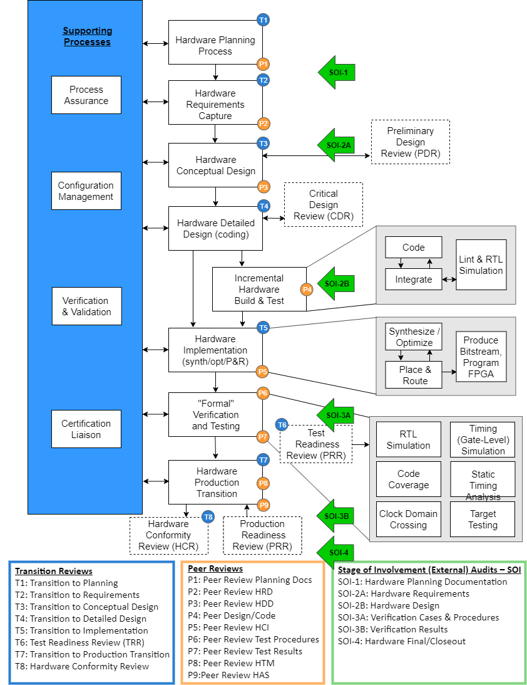

Figure 2-1: Hardware Development Process

The program will use the configuration management capability in PACT for the main repository. Developmental baselines will be generated as mentioned and stored in PACT. Baselining provides the ability to mark specific revisions in order to create a set of files so at any time a certain build or environment can be recreated. Formal baselines (HC1) will also be in PACT.

**Baselines**: A baseline is a known configuration of life cycle data for further activities. Baselines are version controlled and will be established by using the baseline numbering system and stored in PACT. A baseline can be established at any time regardless of the status of the data. Baselines can be established for the purpose of a single or multiple artifact by executing the activities as defined in this section below. A baseline of a Hardware Configuration Index identifies a complete baseline of the hardware item by uniquely identifying the requirements, design, verification procedures, verification environment, source code, implementation scripts and the development environment. A baseline **shall** be established before data/artifact is submitted for a peer review. According to the peer review process, a baseline is needed for artifact review. Baselines can also lead to a release of the artifact.

**Release**: A lifecycle item can be released only after a peer review has been successfully performed according to the Peer Review Process. See section 3 Hardware Releases for further information about document releases. Lifecycle items shall be released in the sequence specified in Figure 2-1: Hardware Development Process (i.e. plans, requirements, test, code, etc.).

Changes to any of the files, once released, would require a specific Problem Report, which is then investigated by the Change Control Board (CCB). If the investigation finds that the problem needs to be fixed, a (PR) is created as a problem report using the PACT tool, and the responsible individuals are assigned to complete the PR. Once the document or file is modified, reviewed, and approved, it will be re-baselined. Each file change has a history of all the revisions made and can be reverted to a previous version if necessary.

The following baselines are to be used (See Figure 0-1: Document Control Flowchart):

* Planning Document Baseline – All necessary documents for completion of the Planning phase are to be in the PACT project repository upon approval and release and under Problem Report (PR) control.
* Requirements Document Baseline- All FPGA requirements documents for use in the design phase are to be in PACT and under PR control.
* Design Document Baseline- All FPGA Design documents for use in the design phase are to be in the PACT and under PR control.
* Code Baseline- FPGA Version #1 Baseline– All necessary hardware code to be checked into the PACT and under PR control.
* Verification Test Procedures Baseline – All necessary test bench procedures to be checked into the PACT and under PR control.
* Production Release Baseline – All necessary final production data to be checked into PACT and under PR control.

As part of a completed process transition gate the versions and ID’s of these artifacts will be documented in the Hardware Configuration Index, Hardware Verification Cases and Procedures, Hardware Verification Results, and the Hardware Accomplishment Summary.

# Hardware Releases

Formal DO-254 HC1 releases will be managed in the PACT project. In support of a release to the PACT system a letter revision release will be generated. The baseline will consist of the all files necessary, the part number and identifying baseline number, and the associated CRC. Any ECO’s, DCR’s will be created and submitted to the ERP system where all contents of the package can be identified, traced, and delivered to production as needed. See **Figure 0-1: Document Control Flowchart**.

## Hardware Configuration Index

The Hardware Configuration Index uniquely identifies a hardware baseline with the complete and correct set of life-cycle data.

The Hardware Configuration Index (HCI) identifies the baselined configuration of the Hardware.

For this program, it will identify the:

* Hardware product
* Each HDL code component
* Hardware Lifecycle data
* Archived release media

## Document Release

Documents that are released shall have been peer reviewed according to the Peer Review Process prior to the release. Thus, the required input to the document release is a peer reviewed baseline of an artifact

The configuration management representative will ensure that the objectives of the configuration management process are satisfied.

# Problem Reporting and Resolution

Problem reporting shall be used to track changes to lifecycle data that have been released as HC1 artifacts in the PACT CM system. **Figure 0-1: Document Control Flowchart** above depicts this relationship. This plan describes a life cycle for problem reporting and CCB which will be utilized within the HC2 process for developmental CM to communicate development changes and in process work prior to a release. Once a data item is released, changes will be done via PR process as defined in this document. ACMEY will conduct the CCB with relevant engineering participation, should updates be required to HC1 items which have been released. For any post-release changes, verification of the change will be performed independently from the problem resolver. The verifier will be responsible for confirming that the changes on the problem report were correctly performed. Once the PR is verified, the updated artifact will be captured in PACT, the PR closed and all lifecycle items captured in the PACT.

## CM Program Specific Roles

Program personnel (members with access to PACT) are assigned roles by the Administrator, with associated functions, rights, and responsibilities within the PACT repository.

The roles established for Program personnel are shown below:

* CM Administrator/CM Manager (Maintainer)
* Developer

### PR Roles

All members can ‘Open’ a PR. For HC2 developmental CM a formal CCB is not required and the CM administrator will facilitate the PR flow.

Only a CM Manager can close a problem report. The CM Manager is to confirm the process was properly completed. Process Assurance will audit this activity. The CM Manager is responsible for compliance to the CM Plan and facilitation of the CCB PR process activities.

## Change Control Board (CCB)

The objective of the CCB is to ensure problems and changes are assessed, and either approved or disapproved. Approved changes are implemented and feedback is provided to affect processes through problem reporting and change control methods defined during the product planning process. For this program, change review activity includes confirmation that affected configuration items are identified, assessment of the impact on critical requirements is accomplished, assessment of problems or other proposed changes is accomplished and decisions for action taken and feedback of problem report or change impacts are recorded.

Change review is accomplished either within Engineering or, for changes impacting products and product releases, a Configuration Control Board is convened to review proposed changes. Each review includes, but is not limited to, the evaluation of technical approach, necessary schedule changes, impacts to other program's activities, and alternatives. Actions are assigned as necessary and problems resolved in an orderly and timely manner. For CCB activity, the agendas and minutes are recorded and maintained by the QA Organization.

## Developmental Problem Reporting

PACT is used for creating and managing the problem reporting for Program development. PACT contains a Problem Report feature that will be used as a tracking system for project development. PACT allows individual PR’s to be used to track all files in the database. PACT will generate a unique PR number for each problem report submitted. A PR can be created by any member of the IEE team. Automatic e-mail notification of all PR activity is made to the team through PACT.

### Problem Reporting Form

PACT’s PR tracking form is shown below:

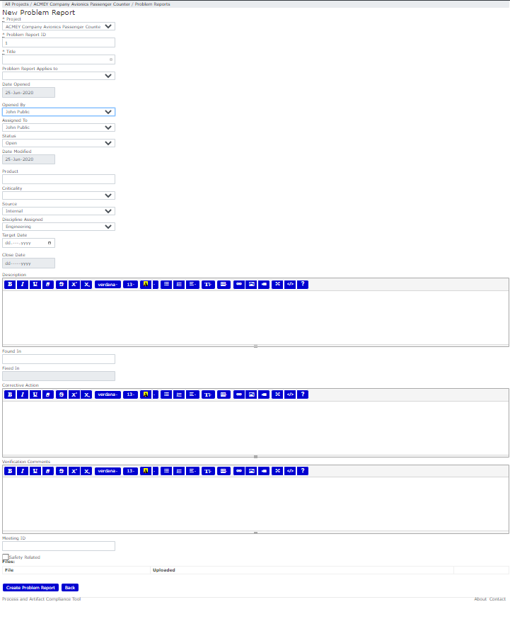 Figure 4-1: Problem Report Form

PR’s are usually created by the engineer responsible for the life-cycle item, or the project lead. The primary function of the PR is to enable the resolver to modify one life-cycle item, or in the case of code, several files if they are related in the change described. When creating a PR, the Title field shall be filled out with a brief description of the reason the work product needs to be created or modified. The “PR Fields” (as shown in Figure 4-2: Problem Report State Flow) shall be completed with a detailed description of the issue and modifications necessary to resolve the PR. The PR must have an analysis of the change impact described or attached to the Issue form. Additionally, the problem shall be categorized according to the “PR Type” field.

### Open PR Management

AC20-189 requires that applicants categorize open PRs to issue proper disposition and ensure that safety related PR’s are reviewed for impact as a priority: Issues are categorized as follows:

* Type 0: A problem whose consequence is a failure - under certain conditions - of the system with a safety impact.
* Type 1: A problem whose consequence is a failure - under certain conditions - of the system; having no safety impact on the aircraft.
  + Type 1A: Failure with a “significant” functional consequence; the meaning of “significant” should be defined in the context of the related system in agreement between aircraft manufacturer and equipment supplier (for instance “cockpit effect”).
  + Type1B: Failure with no “significant” functional consequence.
* Type 2: A problem which does not result in a failure (i.e.: no system functional consequence, fault not detectable by the crew in foreseeable operating conditions).
* Type 3: Any problem which is not type 0, 1 or 2, but a deviation to the rules (plans, or hardware development standards, or applicable PARs/CRIs). If agreed between aircraft manufacturer and hardware supplier, this type should be divided into two sub-types:
  + Type 3A: A “significant” deviation whose effects could be to lower the assurance that the Complex Electronic Hardware (CEH) behaves as intended and has no unintended behavior.
  + Type 3B: A non “significant" deviation to the methodology (plans) that does not affect the assurance obtained
* Type 4: Development.

This categorization shall be included in the descriptive fields of the problem report ticket. For open PR management, the goal is to close all open PRs against the program. Specifically, the final submittal for the HAS will include a complete list of any open PRs and the categories of these as described here in this section. All type 0 and 1A PRs will be closed at the time of final certification and any other categories will provide justification and analysis as to why they can remain open with no safety effect. This justification will be recorded in both the PR and the HAS.

### Problem Report Path to Completion

One PR is required to make modifications for each life-cycle item that is to be changed. For example, if the HRD must be modified after initial release to add (or correct) any requirement or related group of requirements, then one PR is required. If, in addition to the HRD, another life-cycle item must also be modified, then another PR is required to make changes to that affected document. If the example problem then flows down to code, then an additional PR is needed to modify one or more code files that fall under the scope of the initial PR.

All work product items that have been modified under a PR must be listed with the document title which includes, in addition to the revision, a version identifier such as Xx (meaning development baseline version X1, X2, etc.) in the PR along with a complete description of what was changed. The PACT tool will show a log of items changed and placed in the HC1 repository. Consequently, for every change made, the user shall provide an associated log message for that change. This method allows the user to later determine what changes were made and why. This also provides another detailed log of the development process.

#### Documents

All changed items under any PR shall be identified with unique name and/or part numbers.

Once all the changes have been made to the document life-cycle item(s) and all fields in the PR have been completed, the resolver will store the lifecycle item with the file name modified to reflect the review iteration number in PACT and notify the verifier the findings have been addressed. The verifier will then review the updates and complete the checklist and save the checklist with the reviewed lifecycle item.

Once all items on the associated checklist pass, the PR is then considered verified, and the final checklist is stored in the same folder as the reviewed lifecycle item.

At this point the CM Manager will check to assure the tracking items are properly stored in PACT, and the associated PR is fully completed. The CM Manager will move the PR to the Closed state. See Figure 4-2: Problem Report State Flow**Error! Reference source not found.** for PR state flow with associated explanation in Table 4‑1: PR State Definition Table for each state.

**NOTE**: the PR CLOSED state cannot be reversed.



Figure -: Problem Report State Flow

| **Item No.** | **State** | **Description** | **Transition Criteria & Responsible Role** |
| --- | --- | --- | --- |
| 1 | Open | Initial state of a PR. The PR Title field completed with the proper PR fields filled out. | Informational PR fields are completed.  Responsible: ORIGINATOR |
| 2 | Investigate | The Problem is assigned to a cognizant engineer to acquire an acceptable amount of information for the CCB to make a decision. | PR should contain enough information at this point for the CCB to make a decision on disposition.  Responsible: Cognizant Engineer |
| 3 | Deferred | The CCB has determined that the issue is not safety related **and** the resolution is too costly in time or resources to proceed at this point. | PR may remain in this state indefinitely, or may be reactivated based on circumstances or other input. However, if the PR remains in the Deferred state all involved parties, including certification (DER) must agree. Additionally, all PR’s in the deferred state must be listed in the HAS.  Responsible: CCB/Project Management |
| 4 | Rejected | CCB determined the reason the PR was created was not a problem, or a duplicate of a problem addressed in another PR. PRs cannot be rejected if the content addresses any safety issue, or legitimate defect.  Though recorded and kept in the tracking system, the PR will remain in this state indefinitely. | No actual unaddressed defect, and reason for rejection is provided.  Responsible: CCB |
| 5 | Assigned | Resolver is assigned to perform the necessary corrections guided by the Description field in the PR. | Resolver has the resources available to proceed with the resolution.  Responsible: Resolver. |
| 6 | Implemented | Resolver has implemented the corrective actions according to description field in PR. | Resolver has completed the necessary modifications/additions to the lifecycle item.  Responsible: Resolver |
| 7 | Verified | Verifier reviews modifications and records any errors or discrepancies in the PR if found. If errors remain, the lifecycle item is returned to the Resolver for rework. If all work is correct, the verifier completes the checklist and the necessary fields in the PR. | Either Verifier discovered some repairs not made, or PR fields unaddressed: return to Implemented, OR Verifier has no further findings, checklist is completed and saved and PR is moved to Closed  Responsible: VERIFIER |
| 8 | Closed | All work pertaining to the problem addressed in the PR is completed.  another PR should be opened under the same parent PR to address the missing work. The new PR must also reference this CLOSED PR number so that clear artifacts are available to trace the issue to closure. | CM Manager has verified all work described has been performed, PR fields complete, all necessary information attached to the PR.  Responsible: CM Manager |

Table ‑: PR State Definition Table

#### Code

The storage and PR process for code is essentially the same as documentation. The configuration management ```of code requires the individual files to have both unique names and version numbers. The files that make up the entire build will also have both a baseline name and a version when released.

For modifications to code, the same process will be followed concerning the creation of the associated PR for modifications or reviews. The checklists will also be stored with the associated PR and code in PACT so that artifacts concerning the description of changes made, which files were involved, and to which PR the changes were related.

# Change Control

Control of all life cycle data is done by using PACT. PACT will be used for managing, problem tracking and requirement tracing of all lifecycle items.

Each file that is applicable to the Program is added to or developed in PACT. Any changes made to any files are automatically archived with author, revision, date and description of any changes in the associated PR. Changes to any post-release lifecycle items will have associated PR’s tracking all changes.

In addition to the baseline CM control of individual data items produced throughout the development of the Program, a full baseline creation can be generated of the full data base at given points in the development life cycle. The CM Manager is responsible for control of the baseline repository and to ensure that proper signatures and reviews are captured.

The following sub-sections describe the archiving standards defining the procedures, methods and criteria to be used to archive lifecycle data used to develop and maintain this project.

## Development Change Control

Control of hardware design and its associated documentation begins when a Hardware file or document is added to the applicable project file in PACT as a developmental baseline. Baselines of documents correspond with transitions in the development life cycle as defined in the Hardware Development Data is controlled in accordance with the control category defined in DO-254 for DAL assigned as defined in the life cycle data section of the PHAC. Revisions of all changes to data items are automatically archived electronically for each item.

## Production Change Control

Production Change Control is managed by the identified ECO/DCO mechanism that relies on the controlled delivery of any production engineering input.

## Change Review

The CCB shall conduct a review of all open defects/changes associated with a candidate Baseline-level or Release-level configuration to ensure that no high-priority PRs remain unresolved, and to ensure that all PRs designated as Low-priority by the Project Manager are correctly categorized.

## Configuration Management Audit

The ACMEY quality assurance group shall perform periodic audits on configuration management. Refer to the Hardware Process Assurance Plan contained in the PHAC for more details.

## Control Categories & Program FPGA Hardware Design Lifecycle Data

The Hardware Control Categories (HC1 & HC2) are as defined by DO-254 for the DAL level assigned. The PHAC for the hardware item contains the life cycle data table and the control category for each item produced. Refer to the project PHAC for further details.

# Storage and Retrieval

The PACT CM repository is hosted on an AWS ITAR component cloud-based server. This is a hosted server system and set up with daily 30-day rotating backups performed every 10 minutes, every hour and off-site every day to a server which is also backed up daily. PACT provides a web interface service to manage the archival and development tools for CM. PACT (the database) is accessed through the PACT web interface. The security includes encrypted server access, SSL 128 bit, redundant RAID+1 storage devices, secured site perimeters, proximity badge access, digital video surveillance, 100% Redundant Cisco Network, gigabit backbone, encrypted data transfer via HTTPS (128-bit SSL Verisign certificate), dedicated hardware firewalls on all publicly-facing servers, authentication via encrypted multi-master authentication system. Database servers are completely multi-site redundant.

Records that are retained in any other form other than hardcopy (Electronic media or Magnetic media), will be stored and protected to prevent tampering, misuse, damage or loss of data due to environmental conditions or fire. Electronic media records are backed up and stored offsite in a protective and safe environment. Locations for record storage will be reviewed during internal audits. Records are stored in such a manner so as to be readily retrievable and identifiable.

# Environment Control & Tools

All the tools used in the development and programming are commercially available tools.

| Table 7‑1: Hardware Development and Verification Tools | | | | |
| --- | --- | --- | --- | --- |
| Tool | Tool Description | Applicable  Process | Qual Required* | Version(1) |
| PACT | Requirements Capture | Requirements Generation | No | 1.3 |
| Problem Reporting, Document Reviews, and Reviews and Analysis | Design, Verification & CM |
| Requirements traceability | Verification |
| GitLab | HDL Version Control | CM | No | 1.9.7 |
| Mentor ModelSim | RTL Simulator, Code Coverage | Verification | No | DE 10.6b |
| Xilinx ISE | FPGA Design | Design | No | 14.7 |
| Xilinx ISE | Scripting | All | No | 14.7 |
| Libero SoC | FPGA Design | Design Entry, Synthesis & PAR | No | 12.4 |
| MS Excel® | Checklist Template Management | Project Customization | No | 2013 |
| Data Capture | Project Development |
| MS Visio® | Flow Chart and Diagram Program | Project Development | No | 2013 |
| MS PowerPoint® | Meetings and Presentations | Project Development | No | 2013 |
| MS Word® | Project Schedules, Milestones, and to document customer action items | Project Development | No | 2013 |
| Windows 10® Pro  (64-bit) PC | Development Platform | Project Development | No | N/A |

# Sub-Tier Suppliers

Patmos will be supporting DO-254 efforts and providing DER services. Activities related to developmental configuration management, peer reviews, and planning and document development will be supported by Patmos DO-254 experts.